Tianjin UKriver Science & Technology Co.,Itd

Product Specification

Customer name:

Customer audit:

Product name: TFT LCD display

Product model: UKC3

Data of issue:

Approval:

Product Name
- TFT LCD display; model: UKC3.

2. Suppliers
TIANJIN UKRIVER SCIENCE & TECHNOLOGY CO.,LTD

3. Electrical Parameters

1.77 inch IPS screen

24V/36V/48/52V battery supply

Rated power of instrument :1W

Off leakage current <1uA

Working current supplied to controller:100mA, Max output current to controller: 300mA

Operating temperature: -20~70℃

Storage temperature: -30~80℃

4. Dimensions & Material

ABS product shell, LCD transparent window is made of high strength Acrylic which is imported, Product holder material is glass fiber mixed with nylon.
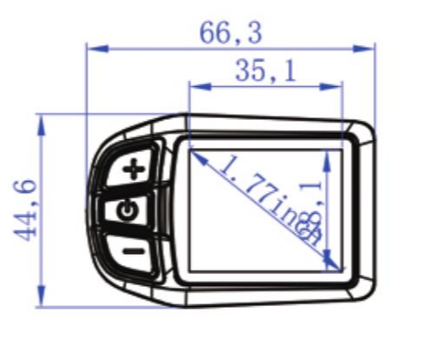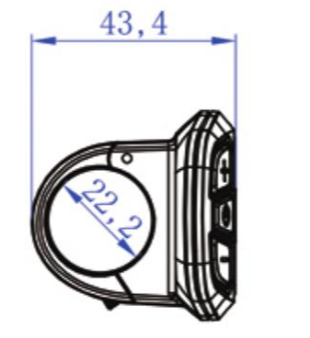

5. Features

5.1 High-contrast 1.77 inch IPS colorful matrix screen.

5.2 Speed display: Display real time speed.

5.3 Kilometer/Mile: Can be set according to customers’ habits.

5.4 Intelligent power indicator contains below: It can provide a stable power indication through the optimization algorithm. The power is not affected by the start-stop fluctuation of the motor. If the system supports battery communication, the accurate percentage of power will be displayed.

5.5 Adjusting 5 levels backlight brightness: 1st level is the darkest, 5st is the lightest

5.6 9-level Assist: 3-level/5-level/6-level/9-level is optional.

5.7 Mileage indicator: Odometer/Trip distance/Riding time.

5.8 Error code indicator.

5.9 Software upgraded: Software can be upgraded through UART.

5.10 Speed measuring magnetic steel regulating function: The number of speed measuring magnetic steel can be set.

5.11 Speed limited from 1-100Km/h.

5.12 Current limited from 5-30A.

6. TFT screen instructions
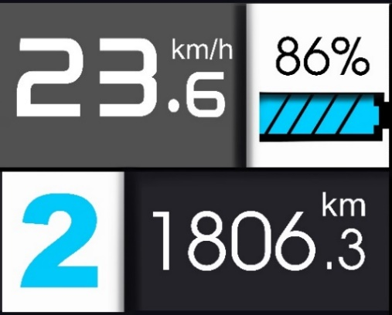
Mileage
Assist level
Speed data
Battery indicator

6.1 Speed display: Km/h or MPH.

6.2 Battery display: Voltage data and display model is optional.

6.3 Level display: 0-9 levels, P means 6Km/h.

6.4 Mileage display: Display mileage accumulation.

7. Functional Description
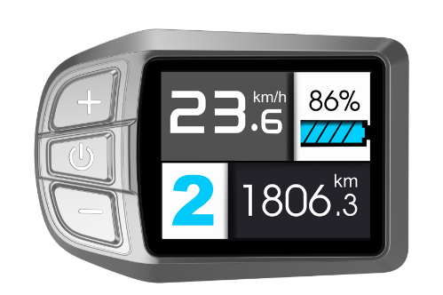
up
down
power

7.1 Power On/Off
Press and hold button for 1 second, it can turn on/off the display. The Display will automatically shut down when there is no operate & ride for X minutes (X could be 0~9).
Power
*If the display has been set power-on password, you need to input the right password when starting.

7.2 Assist level operating
Short press UP/DOWN button can change the assist level. Top assist level is 5,0 for neutral. Level quantities can be adjusted according to the customer’s requirements.
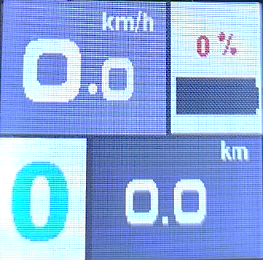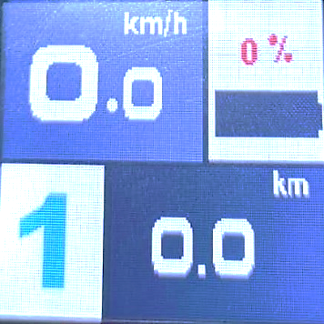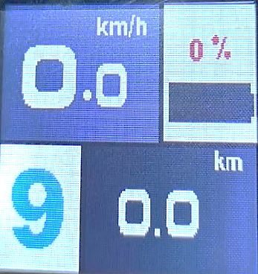
The screen display of the PAS level adjust

7.3 Headlight/Display model change
Press and hold UP button for 1 second, the headlight will be open (controller support is needed) and change the daytime/night model. Press and hold UP button for 1 second again, lighting will be closed and change the display model.
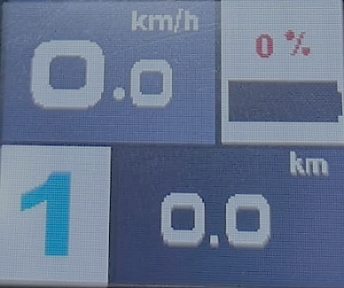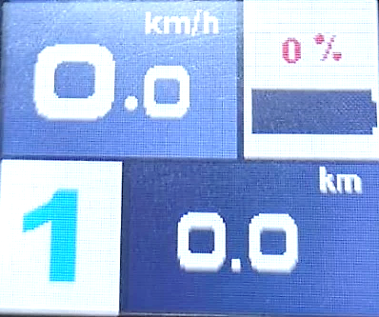
Daytime model Night model

7.4 Walking mode（6km）
Pressing and holding DOWN button for 2 seconds can get into walking mode, then the display will show P, when release the button, it will be out of the mode.
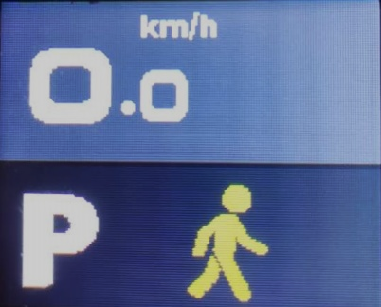
The display of the walking mode
*This feature needs to be supported by controller.

7.5 Information
Press button for 1 seconds can get into information menu, it will show Odometer/Trip distance, and Riding time.
Power
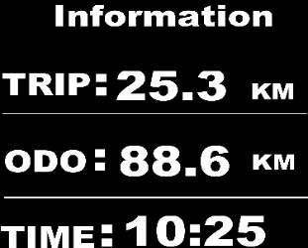
Information menu

8. MENU Parameter setting
In the state of power on, press the button twice (time interval must be within 0.3S), the system will enter the menu parameter setting state, in this state, users can set the parameters, press button twice again to quit setting state (time interval must be within 0.3S).
Power
Power
*Display will quit the menu automatically when there is no operation for 30 seconds, In the riding state (speed is more than 0), entering setting state is not allowed, when riding in the menu state (speed is not 0), it will quit menu setting state.in the advanced setup interface, when you press switch, it’s not able to quit menu.
Power

8.1 Brightness
Power
Press button to enter the setting menu, adjusting the brightness 1-5 by pressing UP/DOWN button, 1 is the darkness, 5 is the brightness.
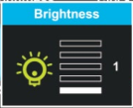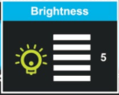
Adjusting the brightness interface

8.2 System
Press UP/DOWN button can change different function, entry into default by pressing
Button, press UP/DOWN button again will change content, pressing button returns to previous menu.
Power
Power
Default and functions:
Unit system Metric/Imperial
Power system 24V/36V/48V/52V
Power indicate Percent/Voltage
Auto assist ON/OFF
After finish setting, choose EXIT, returns to previous menu.

8.3 Auto off 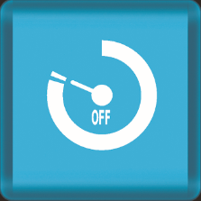
Press UP/DOWN button to change the auto power off time, from 1 to 9, the number represent time (minutes) to shutdown, default value is 5 minutes.
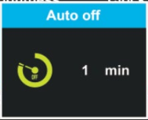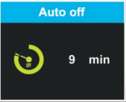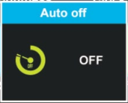

8.4 Wheel
Press UP/DOWN can change the wheel setting, optional wheel diameter is 16/18/20/22
/24/26/27/27.5/28/29/30/31/32/34 inch, 51cm~255cm represent wheel circumference (this needs protocol support).
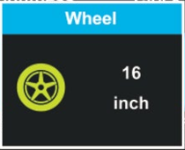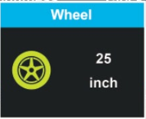

8.5 Advance setting
Power
Press button to enter advance setting menu, adjusting password by pressing UP/DOWM button, if the password is right, you can enter the Sub menu of advance setting, password has 4 numbers, default password is ‘1801’.
Defaults and functions:
Speed limit **km/h
Current limit **A
Assist levels 3/5/9/6: 3 means 3 levels; 5 means 5 levels; 9 means 9 levels; 6 means 9 levels.
Poles in motor 1~15
Throttle 6km Y/N
Assist Poles 3~15
Throttle Level Y/N
Clockwise Y/N
After finish setting, choose Exit, Previous Menu.

8.6 Factory setting
Enter Factory setting menu, set YES will restore all parameter to factory settings.
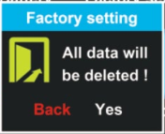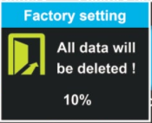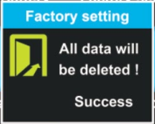

8.7 Password
Press button to enter the password setting menu. Press UP/DOWN button to adjust the password number and get into setting menu, choose Start Password and choose Turn ON/Turn OFF, it means open/close password; choose Reset the Password menu, it will get into the new password setting menu. default password is ‘0000’.
Power
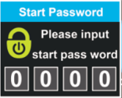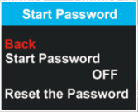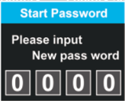
Input password Choose Input new password

8.8 Exit
Select Exit and press to return to the main menu.
Power

9. Error Code define
UKC3 can provide error indication for vehicle default, and display error code and error description on screen when fault is detected.

10. Assembly instructions

Please pay attention to the screw’s torque value, damages caused by excessive torque are not within the scope of the warranty.
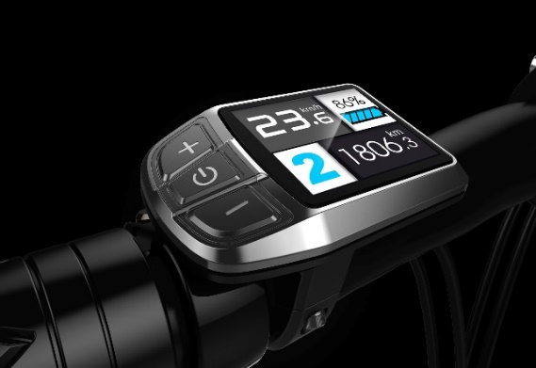

11. Connect descriptions
Fixing screw
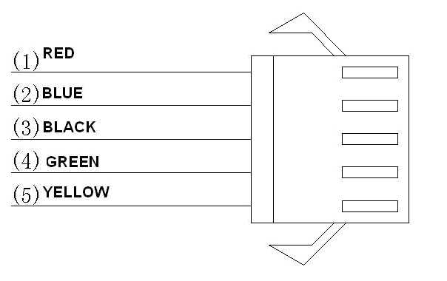
- Red wire: Anode(24V/36V/48V)
- Blue wire: Power cord to the controller
- Black wire: GND
- Green wire: RXD(controller->display)
- Yellow wire: TXD(display->controller)

